**ASSIGNMENT -1**

**NAME – VISHNU S**

**ROLL NO – 202107185**

**REG NO – 211721243185**

**1.ADDING DATASET TO EXCEL**

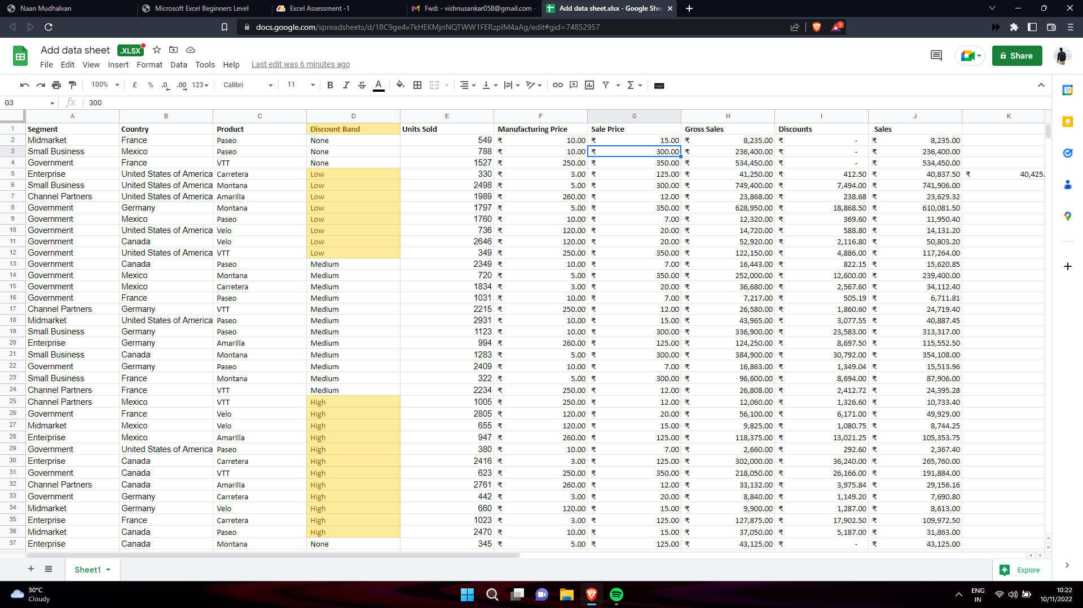

**2. TEMPLETE**

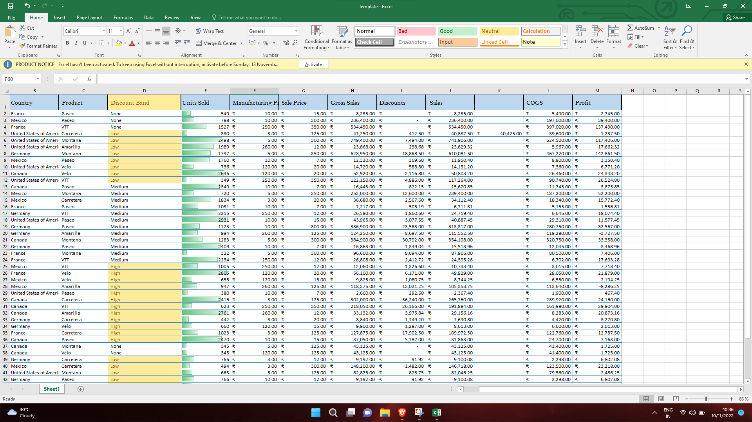

**3. WRAPPPING COUNTRY**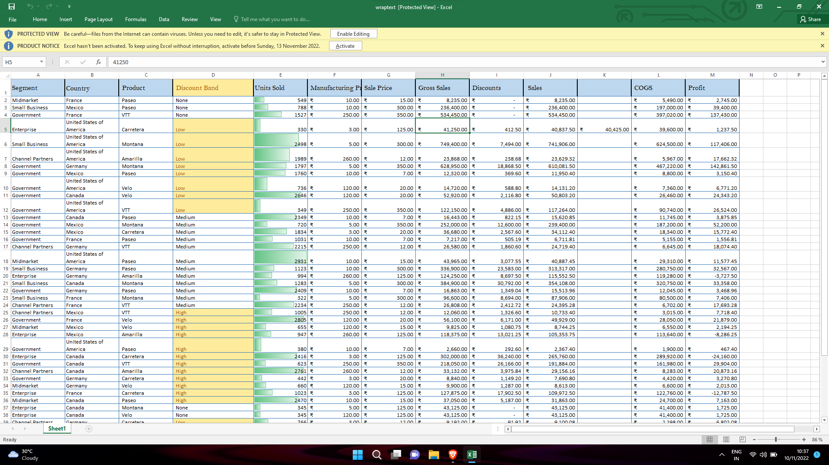

**4. CHANGING CURRENCY**